Wind-farm array orientation strongly shapes migratory-bird collision exposure with little energy loss
— A geometric exposure screen of Western European offshore and onshore wind farms
Abstract
The tension between wind-energy expansion and migratory-bird conservation has made collision exposure a central constraint on the ecological sustainability of wind power. Most existing mitigation measures rely on operational-phase investment, whereas a variable that can be fixed before construction and costs almost nothing has long been overlooked: the orientation of the turbine array. When the array is aligned parallel to the migration direction, birds pass through the inter-row corridors and geometric exposure is minimal; when it is perpendicular, they repeatedly traverse the rotor-swept plane and exposure is maximal. Here we treat array orientation as a quantifiable ecological design variable and test its role across offshore and onshore wind farms in Western Europe. Collision exposure is highly sensitive to orientation, and this sensitivity holds consistently across independent data sources; orientations optimised purely for energy yield systematically depart from the exposure optimum and retain avoidable exposure; and most of this avoidable exposure can be recovered through a limited rotation at an energy cost of less than 1% of annual energy production. Array orientation is therefore a very-low-cost, long-underestimated ecological design lever that warrants routine incorporation into site-level screening.
Keywords: wind-farm array orientation; migratory-bird collision; geometric exposure; energy–ecology trade-off; wake model
Introduction
Wind power is a core pillar of the clean-energy transition, yet its rapid expansion increasingly conflicts with migratory-bird conservation. In the contiguous United States alone, an estimated 140,000–330,000 birds are killed each year by collisions with wind facilities^{[1]}; a trait-based global assessment further shows that migratory species are disproportionately vulnerable to collision owing to their migration strategies and long-distance dispersal, with highly vulnerable species concentrated along migratory flyways^{[2]}. Collision risk has thus escalated from a local technical problem into a critical constraint on the ecological sustainability of wind power.
Collision risk is not randomly distributed but is systematically shaped by the spatial relationship among flight height, migratory corridors, and turbine distribution. Flight height is the single most important determinant: the fraction of time a bird spends within the rotor-swept zone (roughly 20–150 m) directly determines its exposure^{[3]}. In Europe and North Africa, GPS tracking of 1,454 individuals across 27 species showed that roughly 13.6% of the area is sensitive to turbine height, with sensitive zones concentrated along major migration corridors and coastlines^{[4]}. The widely used Band model takes flight-height distribution and avoidance rate as its core inputs, expressing collision probability as a function of bird morphology, flight speed, and turbine geometry^{[5]}; recent GPS tracking of 143 whimbrels further showed that migrating individuals overlap substantially with the rotor layer when crossing offshore wind farms, accompanied by pronounced horizontal avoidance and detouring^{[6]}. The spatial relationship of turbine siting and layout relative to the migration direction is therefore a first-order determinant of collision exposure.
Existing mitigation measures fall broadly into three categories, each with structural limitations: macro-scale siting relies on sparse species-distribution data and is hard to implement in data-poor areas; operational curtailment depends on real-time bird detection and sacrifices generation; and turbine-type and spacing design (raising hub height, widening row spacing, staggered layout) is constrained by the boundaries of the approved site^{[7]}. Prior work has focused largely on the barrier effect of wind farms on migration^{[8]} and on individual avoidance behaviour^{[9]}—the former characterising the extra flight distance birds incur to detour around farms, the latter explaining the mechanisms of avoidance. Recent operational quantification of curtailment underscores its cost: avoiding 50% of potential collisions requires losing roughly 1.2% of annual energy production, and avoiding 90% requires 7.6%^{[10]}. By contrast, a geometric variable that can be adjusted before construction at essentially no cost—the orientation of the turbine array—has long gone unquantified.
The role of array orientation follows from a simple geometric fact. When turbines are arranged in rows, birds crossing parallel to the rows can pass through the inter-row corridors with minimal exposure; those crossing perpendicular to the rows must repeatedly traverse the rotor-swept plane, maximising exposure. Accordingly, the relative angle between array orientation and migration direction determines collision exposure directly through a sin² function. Orientation is therefore a near-zero-cost ecological design lever requiring no additional land or material—achievable simply by rotating the array on the pre-construction drawings.
Here, across 55 offshore wind farms with measured migratory-bird directions in Western Europe (29 from VPTS weather radar, 26 from the Bauer grid) and 4,191 onshore wind farms, we treat array orientation as a quantifiable ecological design variable and test this hypothesis along four dimensions: whether migration direction makes collision exposure highly sensitive to orientation; whether the energy-optimal orientation retains a large amount of avoidable exposure; whether a limited orientation change can capture most of the reducible exposure; and whether these reductions come at a minimal energy cost (Fig. 1). If all four are affirmative, orientation can serve as a design variable that yields substantial ecological benefit at less than 1% energy loss, rather than merely an engineering parameter that determines generation performance.
Throughout the paper we use five core concepts (Table 1) and distinguish three levels—collision risk (expected number of collisions), collision exposure (the un-calibrated approximation), and collision mortality (the measured, mortality-calibrated quantity). All “exposure reductions” reported here refer to the relative decline in geometric exposure, uncalibrated for species, flight height, and mortality, and are therefore not equivalent to a measured decline in collision mortality; until such calibrations are completed, the geometric angle serves for screening only.
Table 1 | The five core concepts used throughout the paper, with definitions and units.
Concept | Definition | Units
Collision risk | Expected number of collisions arising after birds traverse the rotor-swept zone; without mortality calibration it is termed collision exposure | birds/yr; or exposure index
Collision hazard zone | Grid cells or wind farms where collision risk exceeds a threshold; not identified by coarse flyway overlap | grid cells, wind farms
Direction-reducible risk | Risk under the current orientation minus the lowest risk among alternative orientations | birds/yr; or %
Ecological adjustment angle | Minimum angle from the current orientation to a target orientation | degrees
Energy–ecology trade-off | Relationship between the collision risk reduced by re-orientation and the associated AEP loss | avoided collisions/GWh; or %/%

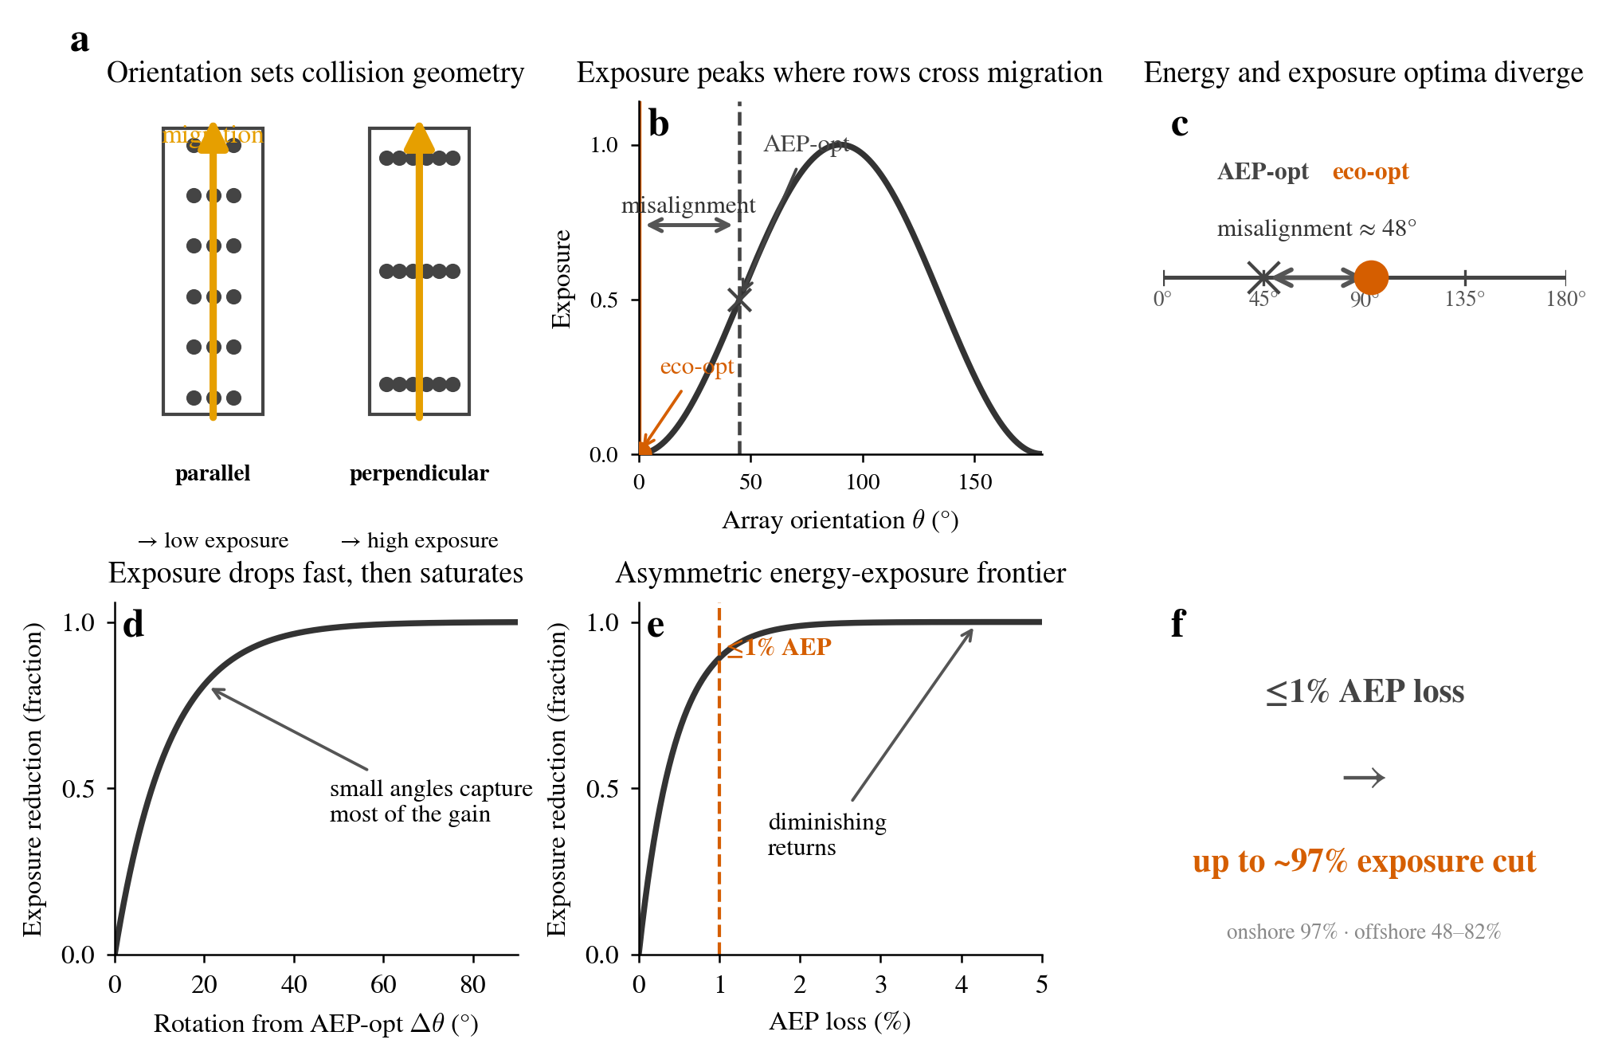
Figure 1 | Study framework (graphical abstract). Fig. 1a is the orientation geometry: when the array is parallel to the migration direction, birds pass through the inter-row corridors with minimal exposure; when perpendicular, they repeatedly traverse the rotor-swept plane with maximal exposure. Fig. 1b is the conceptual exposure–orientation curve, showing the offset between the AEP-optimal and minimum-exposure orientations. Fig. 1c expresses this offset as the angular difference between the two optimal directions (≈48°). Fig. 1d is the conceptual exposure-reduction curve: the first few tens of degrees of adjustment capture most of the benefit, followed by saturation. Fig. 1e is the conceptual energy–exposure frontier: ecological benefit is concentrated within roughly 1% energy concession, after which marginal return declines rapidly. Fig. 1f summarises the core conclusion: no more than 1% energy concession yields up to ≈97% geometric exposure reduction (onshore 96.9%, offshore 47.6–82.1%).
The study covers two Western European settings. Offshore, 171 wind farms have engineering-grade AEP orientation curves, of which 55 have measured migratory-bird directions (29 from VPTS weather radar, 26 from the Bauer grid). Onshore, per-turbine coordinates from OpenStreetMap (100,327 turbines) and wind-resource data from the Global Wind Atlas are fed through the Jensen wake model to compute AEP(θ) curves; of the 5,869 farms for which AEP was computed, 4,191 fall within the coverage of the Bauer migratory-bird direction product and enter the trade-off analysis, while the remaining 1,678 (mainly in the UK/Ireland, northern Europe/Baltic, and Iberia) fall outside this range and are excluded (Fig. 2).
The threat from migratory birds during the migration season shows quantifiable spatiotemporal signatures, establishing the premise that the threat is real and substantial for the orientation analysis: VPTS weather radar measured mean migration-season densities of 12–135 birds/km³ (spring 12–24, autumn 16–135), peak instantaneous density of 1,287 birds/km³, and a maximum single-station autumn total flux of ≈825,000; roughly half of the birds (rotor-layer fraction 0.23–0.71, median ≈0.51) enter the rotor-swept height—Supplementary Fig. S1 shows that this height overlap is systematic, providing the ecological premise for the subsequent geometric-exposure analysis.
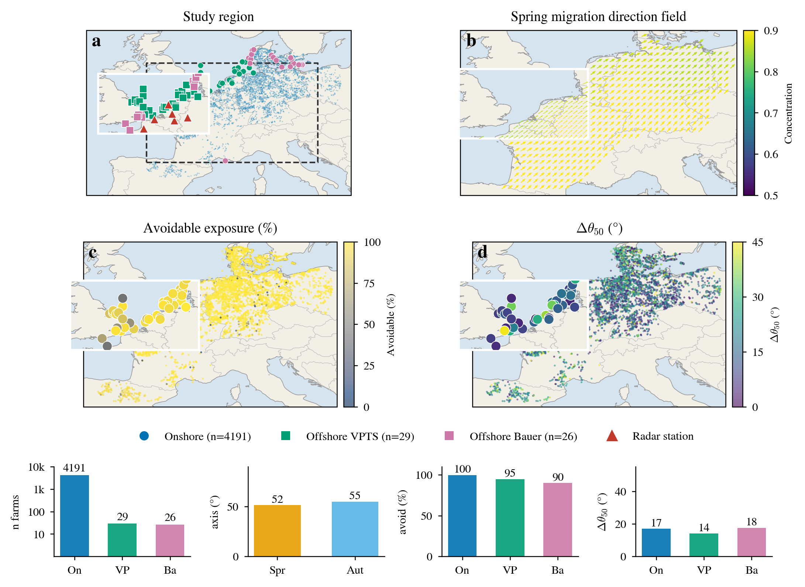
Figure 2 | Study region, data coverage, and spatial patterns. Fig. 2a is an overview of the Western European study region: 4,191 onshore farms (blue dots), 55 offshore farms (VPTS green, Bauer purple squares), and VPTS radar stations (red triangles); the dashed box marks the Bauer grid extent and the inset enlarges the North Sea. Fig. 2b shows the spring migration-direction field (arrows for flight direction, colours for directional concentration), with an inset enlarging the North Sea. Fig. 2c shows the spatial distribution of the onshore reducible-exposure fraction (avoid). Fig. 2d shows the spatial distribution of Δθ50. The bottom bar charts give the number of farms per group (log scale), the spring/autumn dominant axes, the median reducible fraction, and the median Δθ50.
Results
All quantitative results in this paper rest on a simple geometric mechanism. Consider a single-row wind farm through which birds fly in a fixed direction: when the array is parallel to the migration direction, birds pass through the inter-row corridors and barely traverse the rotor-swept plane, so geometric exposure approaches zero; as the array is rotated to be perpendicular to the migration direction, birds must cross the rotor-swept plane once for each row they pass, and geometric exposure reaches its maximum. The span between these extremes is fully described by a sin² function—0 at parallel, 1 at perpendicular, rising monotonically in between. Where a real farm's orientation falls within this interval, and how much energy it costs to move it toward 0, is the quantitative content of the following sections.
All “exposure reductions” reported here refer to the relative decline in geometric exposure, uncalibrated for species, flight height, avoidance rate, and mortality, and are therefore not equivalent to a measured decline in collision mortality; the conclusions of this paper are thus screening-level judgements, not calibrated mortality reductions.
To unify the quantitative analysis that follows, we first define five metrics, which are henceforth referred to by their physical meaning rather than as isolated numerical values: the “directional sensitivity amplitude” rel = (E_max − E_min)/E_max measures the relative magnitude by which exposure can be changed through array rotation alone; the “reducible exposure fraction” avoid = 1 − E_min/E(θ_econ) measures the fraction of exposure that can be eliminated by re-orientation from the energy optimum; the “exposure ratio” E(θ_econ)/E_min measures the factor by which the energy-optimal orientation exceeds the minimum achievable exposure; the “ecological adjustment angle” Δθ measures the smallest rotation needed to move from the energy optimum to the ecological optimum; and the “capture fraction” frac_d measures the share of the maximum reducible exposure recovered after rotating by d°. Together these five metrics answer a single question: to what extent, and at what cost, can array orientation regulate migratory-bird collision exposure.
Migratory direction structure makes collision exposure highly dependent on farm orientation
Migratory bird migration has clear and concentrated directional structure, the prerequisite for orientation to serve as an ecological design variable. Based on observations from 2,025 valid cells across the full Bauer grid, the median dominant spring migration direction is 51.5° (NE) and the autumn direction 234.9° (SW), with median directional concentration of 0.89 in spring and 0.76 in autumn (Fig. 3a, Fig. 2b). Migration is not diffuse but follows a well-defined principal axis, which provides a stable optimisation target for aligning the inter-row corridors with the migration axis. The dominant directions of the two seasons are nearly opposite as vectors (a directed difference of ≈183°), but because collision-exposure geometry is periodic with period 180°, the two seasonal migration axes differ by only ≈3.4°—a single orientation can simultaneously depress exposure in both seasons, so spring and autumn do not form competing constraints requiring compromise. This distinguishes orientation from other ecological mitigation measures: it has a seasonally consistent, geometrically determined solution.
This directional structure translates directly into strong sensitivity of collision exposure to array orientation. Exposure is lowest when the array is parallel to the migration direction and highest when perpendicular, rising monotonically in between (Fig. 3b). Across orientations, the directional sensitivity amplitude (rel, defined above) reaches a median of 99.9% onshore, 97.6% for offshore VPTS, and 93.4% for Bauer (Fig. 3c, Supplementary Fig. S2b); in all three groups, 100% of sites have a sensitivity amplitude exceeding 50%, and the fraction of sites exceeding 80% is likewise 100%. Array rotation alone can change exposure by nearly an order of magnitude. By comparison, operational curtailment and blade-painting warnings, as mature measures, require sustained operational investment and are each constrained by detection reliability and generation loss, respectively; orientation, at near-zero cost, offers an exposure-adjustment range close to the full span. Direction is therefore not a secondary correction to collision risk but a first-order determinant on par with the migration direction itself.
This sensitivity holds universally across all sites. Onshore, offshore, and two independent offshore direction products (the radar-based VPTS and the grid-based Bauer) yield a consistent conclusion: directional sensitivity is a structural feature, not a coincidence of a few sites (Supplementary Fig. S2c, S2a). The three data sources differ enormously—onshore is characterised by purely geometric exposure from a wake model, offshore VPTS comes from weather-radar measured flux, and Bauer from a gridded direction product—yet each independently points to a 93%–100% sensitivity range. This cross-source robustness rules out the possibility that the result is an artefact of a particular measurement approach, and indicates that orientation sensitivity is a property of migration ecology itself, not a product of the analysis method. The planning implication is direct: array orientation should become a routine design variable in every farm layout, just as wake loss already is.
The directional structure of migration, the strong sensitivity of exposure to orientation, and its universality across sites and data sources together establish the premise of this paper: array orientation is a first-order determinant of migratory-bird collision exposure.
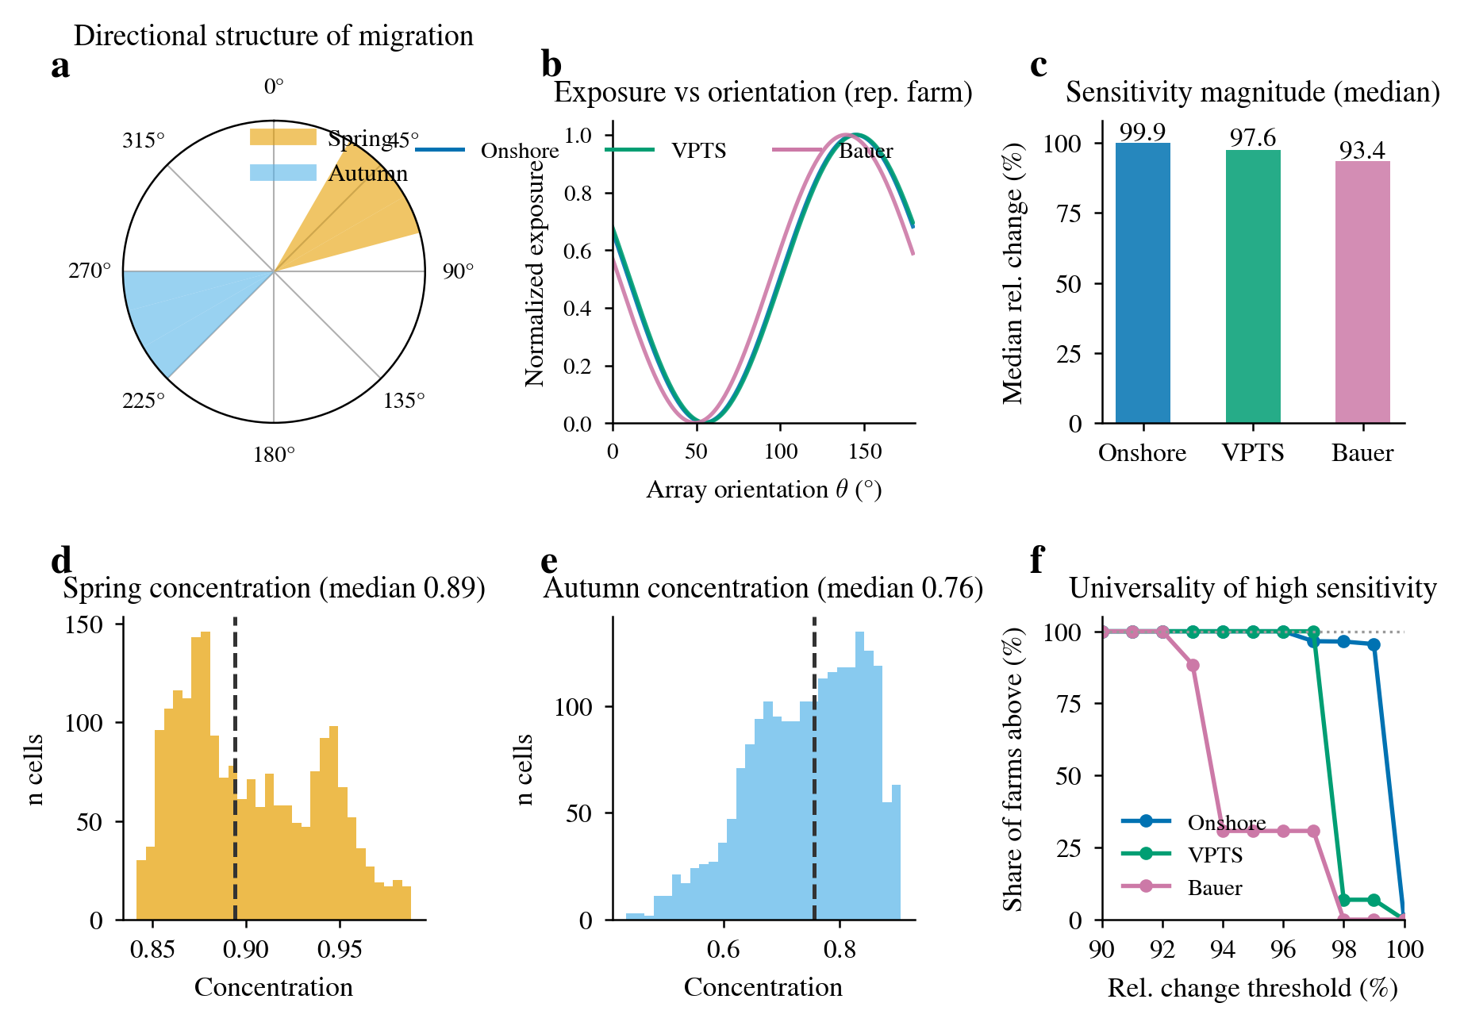
Figure 3 | Sensitivity of collision exposure to array orientation. Fig. 3a is a rose diagram of migration-direction structure (spring orange, autumn blue), showing that spring and autumn are nearly co-axial in exposure terms (differing by ≈3.4°), providing the geometric premise for a single orientation to depress exposure in both seasons; Fig. 3b shows representative exposure–orientation curves (three groups, lowest at parallel, highest at perpendicular); Fig. 3c shows median relative-exposure-change bars for the three groups (99.9%/97.6%/93.4%); Fig. 3d,e show the distributions of spring and autumn directional concentration (medians 0.89, 0.76); Fig. 3f shows the fraction of sites in each group whose relative change exceeds a given threshold (sensitivity holds at nearly all sites). Evidence for the spatial universality of sensitivity is in Supplementary Fig. S2.
Orientations optimised solely for energy yield retain large avoidable exposure
The energy-optimal and exposure-optimal orientations are systematically misaligned. The AEP-optimal orientation generally does not coincide with the minimum-exposure orientation; the median angular difference between the two optimal directions is 48° onshore (interquartile range 29°–60°), 40° for offshore VPTS (20°–50°), and 45° for Bauer (30°–68°) (Fig. 4b, Fig. 4c). This misalignment is not incidental but has a clear physical origin: the energy-optimal orientation is determined by the wind resource (the dominant wind direction), the exposure-optimal orientation by the migration axis, and the two are mutually independent, so the misalignment is systematic rather than a coincidence of individual sites. A misalignment of 40°–48° means that a purely energy-optimised orientation happens to sit at a high position on the exposure curve—close to the “perpendicular to migration” exposure peak, rather than the exposure trough. A single economic objective has inadvertently pushed ecological exposure toward the high end.
The exposure of the energy-optimal layout is far higher than the ecological optimum. Measured by the exposure ratio E(θ_econ)/E_min, the median exposure at the onshore energy-optimal orientation is roughly 600 times the minimum achievable, compared with ≈19× for offshore VPTS and ≈10× for Bauer. The differences among the three ratios themselves carry mechanistic information: the onshore purely sin² geometry approaches zero at “array parallel to the migration axis”, so E_min is extremely small and the ratio is amplified to hundreds of times; the offshore models incorporate flux and flight height, so exposure has a non-zero floor and the ratio falls back to 10–19×. Even under the most conservative (smallest-ratio) offshore convention, the energy optimum still leaves roughly an order of magnitude of reducible exposure; the onshore 600× should be read as an upper bound on geometric exposure whose absolute size is highly sensitive to angular error near the optimum (see Discussion), not as a precise mortality-rate gap.
Most exposure under the energy-optimal orientation can be eliminated by re-orientation. Computed under the unconstrained convention (1 − E_min/E(θ_econ)), the median direction-reducible exposure fraction is 99.8% onshore, 94.6% for offshore VPTS, and 90.0% for Bauer (Fig. 4a). This result moves the question from “can exposure be reduced” to “at what angle and energy cost”: more than 90% of exposure is geometrically removable by re-orientation, so the variables that determine the value of orientation optimisation are the angle change and energy cost required to achieve these reductions.
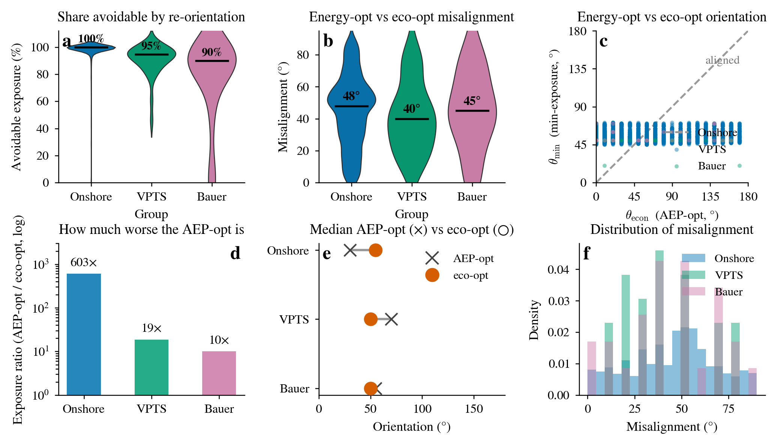
Figure 4 | Misalignment between energy-optimal and exposure-optimal orientations. Fig. 4a is a violin plot of the reducible exposure fraction (avoid) for the three groups (medians 99.8%/94.6%/90.0%); Fig. 4b is a violin plot of the misalignment angle d_full (medians 48°/40°/45°); Fig. 4c is a scatter of the minimum-exposure orientation θ_min against the AEP-optimal orientation θ_econ (the diagonal indicates alignment, deviation from it indicates misalignment); Fig. 4d is the ratio of exposure at the AEP-optimal orientation to the minimum achievable exposure (log axis, medians 602.5×/18.6×/10.0×); Fig. 4e compares the median directions of the AEP-optimal and ecological-optimal orientations for the three groups; Fig. 4f is a histogram of the misalignment-angle distribution.
A limited orientation change captures most reducible exposure
Collision exposure declines rapidly with initial orientation adjustment. Starting from the AEP-optimal orientation, successive adjustments of 5°, 10°, 20°, and 30° capture (medians) 15.3%, 29.9%, 54.8%, and 72.9% of the maximum reducible exposure onshore, 18.9%, 37.8%, 69.4%, and 82.2% for offshore VPTS, and 14.5%, 28.9%, 52.9%, and 73.6% for Bauer (Fig. 5a). Benefits concentrate in the first few tens of degrees, showing a characteristic “fast then slow” shape: the first 20° already yield more than half the benefit, while the final stretch from Δθ80 to the full optimum contributes only the remaining ≈20%. This nonlinearity is not an empirical coincidence but a direct consequence of the sin² geometry—in the misaligned region far from the optimum, exposure has a large first derivative with respect to angle, so a small rotation sharply depresses exposure; the closer to the flat trough of the optimum, the smaller the return from the same rotation. The geometric structure itself makes the first few degrees contribute the most.
A partial orientation adjustment realises most of the ecological benefit. The Δθ50 and Δθ80 required to achieve 50% and 80% of the maximum reducible exposure are 17° and 29° onshore, 14° and 25° for VPTS, and 18° and 30° for Bauer (Fig. 5b, Fig. 2d), all far smaller than the full optimal adjustment angle (48° onshore, 40° VPTS, 45° Bauer). Benchmarked at half the benefit, the required adjustment is only about one-third of the full rotation (17° vs 48°, 14° vs 40°, 18° vs 45°). This comparison has a direct planning implication: a moderate compromise orientation captures most of the ecological value, without needing to rotate the array to the ecological optimum.
The strong early gains hold at most farms, rather than being a mean effect driven by a few extreme sites. The fraction of farms that capture more than 50% of the maximum reducible exposure within an adjustment of at most 20° is 58.3% onshore, 69.0% for VPTS, and 53.8% for Bauer, rising to 73.9%, 79.3%, and 69.2% when relaxed to 30° (Fig. 5c). More than half of the farms achieve more than half the benefit with an adjustment of 20° or less, and nearly seven to eight out of ten farms reach the threshold within 30°. The high yield of small-angle adjustment is thus not a coincidence in the mean but a regularity that holds farm by farm.
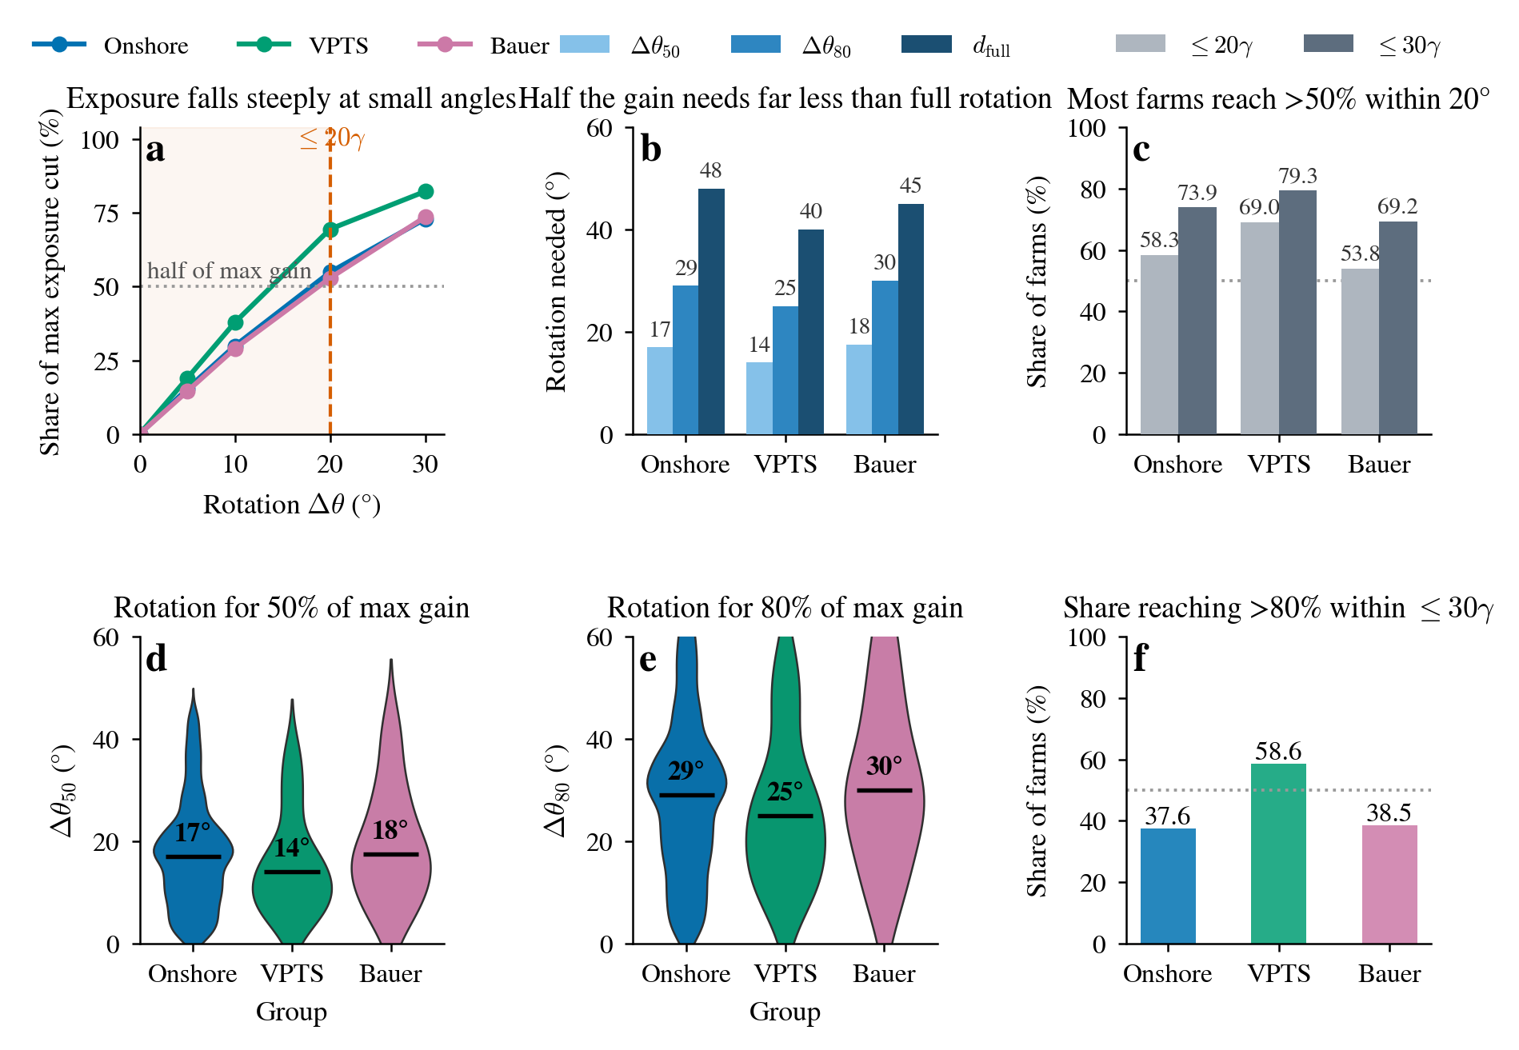
Figure 5 | A limited orientation change captures most of the reducible exposure. Fig. 5a shows the capture curves: the fraction of maximum reducible exposure captured by successive 5°, 10°, 20°, and 30° adjustments from the AEP-optimal orientation (medians), with the grey dashed line at 50% and the red zone ≤20°; Fig. 5b compares the rotations Δθ50/Δθ80 required to reach 50%/80% of the maximum reducible exposure against the full misalignment angle d_full (medians 17°/29°/48°, 14°/25°/40°, 18°/30°/45°); Fig. 5c shows the fraction of farms capturing >50% of the maximum reducible exposure within ≤20°/≤30° adjustment (58.3%/73.9%, 69.0%/79.3%, 53.8%/69.2%); Fig. 5d,e show the distributions of Δθ50 and Δθ80 for the three groups (violin); Fig. 5f shows the fraction of farms capturing >80% of the maximum reducible exposure within ≤30° adjustment.
Most exposure reductions come at minimal energy cost
A small energy concession unlocks large exposure reductions. Under a 1% AEP cap, the mean realised AEP loss is 0.52% onshore, 0.36% for offshore VPTS, and 0.49% for Bauer; the corresponding mean exposure reductions are 82.6%, 72.3%, and 50.1% (medians 96.9%, 82.1%, and 47.6%) (Fig. 6g, Fig. 6h, Fig. 6a–f). A generation concession of less than 1% corresponds to more than half, and in places nearly all, of the exposure reduction. This asymmetry between realised loss and exposure reduction is the core empirical finding of the paper: across the three groups the mean AEP cost is under 0.6%, yet it buys a 50%–83% mean exposure reduction (median 48%–97%).
The energy–exposure frontier is strongly asymmetric. Under a 1% AEP budget, the median fraction of the maximum achievable exposure reduction captured is 98.0% onshore, 88.1% for VPTS, and 74.5% for Bauer—most of the ecological benefit is recovered within a 1% energy concession (Fig. 6g). This asymmetry has a robust geometric root: AEP is flat near its optimum (the definition of an optimum itself requires a zero first derivative), while exposure is exactly steep in the misaligned region (the nonlinear capture curves of the previous section). A very small AEP sacrifice therefore corresponds to a large exposure reduction—ecological benefit concentrates in the early part of the angle change, while energy loss accumulates appreciably only at larger angular deviations. The two are staggered, making ecological benefit at low energy cost structurally possible rather than dependent on a particular wind resource or site.
Ecological benefit saturates rapidly after a low AEP loss. Raising the AEP cap from 2% to 5%, the fraction of farms with no additional exposure benefit is 85.8% onshore, 100% for VPTS, and 69.2% for Bauer; the marginal ecological return of further relaxing the energy constraint has approached zero (Fig. 6g). This saturation delineates a clear optimal investment window: the great majority of ecological benefit is concentrated within roughly a 1% energy concession, and further concessions yield a very low marginal return. For planning, this means orientation optimisation should not be treated as a continuous “energy for ecology” trade-off, but as a single adjustment that can be completed within roughly 1% energy concession, beyond which marginal returns are very low.
The gradient across the three groups (onshore 98.0% > VPTS 88.1% > Bauer 74.5%) reflects not a difference in generation performance or site quality, but mainly differences in the resolution of the direction data and exposure models—the onshore purely geometric model is most sensitive to orientation and has the most concentrated benefit, while the Bauer grid product has the lowest spatial resolution and relatively dispersed benefit. This gradient suggests that, as the precision of migratory-bird direction data improves, the achievable benefit of orientation optimisation may approach the onshore level.
Table 2 | Median geometric exposure reduction under four AEP budgets. Onshore (4,191 farms) is purely geometric exposure; offshore VPTS (29 farms) and Bauer (26 farms) are two independent direction conventions. RR>90% is the fraction of onshore farms whose exposure reduction exceeds 90%. All exposure reductions are relative decline rates with consistent units; the realised AEP cost (mean) is always below the budget cap (onshore 0.26%–1.01%).
AEP budget | Onshore median exposure reduction | Onshore RR>90% fraction | VPTS median exposure reduction | Bauer median exposure reduction
0.5% | 80.0% | 40.6% | 68.8% | 37.7%
1.0% | 96.9% | 64.3% | 82.1% | 47.6%
2.0% | 99.1% | 81.8% | 84.3% | 70.6%
5.0% | 99.3% | 90.0% | 84.3% | 89.3%

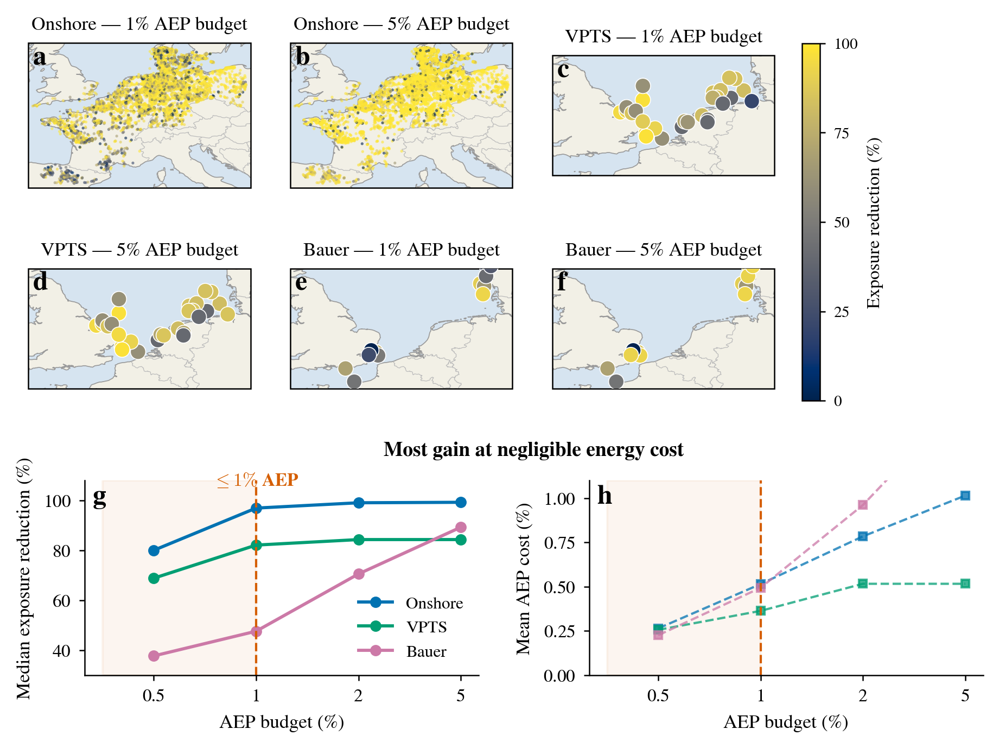
Figure 6 | Energy–ecology trade-off. Fig. 6a–f show the spatial distributions of exposure reduction for the three groups (onshore/VPTS/Bauer) under 1% and 5% AEP budgets; Fig. 6g,h show the marginal trade-off: Fig. 6g shows median exposure reduction versus AEP budget, and Fig. 6h shows mean AEP cost versus AEP budget (red zone ≤1%).
Discussion
The core finding of this study is that array orientation is a long-underestimated, very-low-cost ecological design lever. Under a budget of no more than 1% energy loss, orientation adjustment achieves more than 80% geometric exposure reduction for the great majority of onshore wind farms in Western Europe (median 96.9%) and for offshore VPTS radar farms (median 82.1%), while the effect is limited for offshore Bauer grid farms (median 47.6%). This adjustment requires only rotating the array on the pre-construction drawings, with no additional investment, land, or new materials. By contrast, existing collision mitigation measures are concentrated in operational-phase reduction (such as seasonal shutdown and blade-painting warnings) and siting avoidance^{[7]}, while orientation—a design variable that can be fixed before construction and requires no new input—has long been overlooked. More broadly, this paper reveals a general regularity: in the energy–ecology coupled system that is wind power, the ecological externalities of some design variables far exceed their energy externalities—and orientation is exactly the lowest-cost and most direct-acting of such variables.
The strength of evidence across the four dimensions is not uniform. Directional sensitivity and misalignment are directly supported at the geometric-screening level—measured directional structure, monotonic exposure change with orientation, and systematic misalignment between energy and ecological optima all rely on no behavioural assumptions; the limited change and small cost, by contrast, depend on the shape of the AEP(θ) curve, whose numerical values are highly sensitive to the direction convention and wake model.
The boundary of applicability is clear: orientation optimisation acts only on new farms whose array orientation has not yet been fixed at the planning stage, where rotating the array on the drawings is nearly costless. For already-built farms with fixed orientation, this lever no longer exists, and one should turn to operational shutdown and selective curtailment. The latest operational quantification shows that avoiding 50% of potential collisions requires sacrificing about 1.2% of annual energy production, and avoiding 90% requires 7.6%^{[10]}. The orientation adjustment in this paper is not in competition with these but complementary: the former recovers most geometric exposure before construction at roughly 1% energy concession, while the latter bears the remaining risk during operation; together they form a complete mitigation chain from planning to operation.
The onshore “median ≈97% exposure reduction” is highly sensitive to wake-model strength. When the orientation penalty is amplified by 1.5/2/3×, the median exposure reduction falls to 92%/82%/62% respectively—that is, the uncertainty interval of the core number is roughly 60–95%; the decay constant α is a second-order effect (0.075→0.05 changes the median exposure reduction only from 97% to 95%), and cannot explain the gap in orientation sensitivity between onshore (≈2.8%) and offshore FLORIS (8.8%), a gap more likely to arise from the models themselves and the direction-data conventions.
The offshore direction conventions diverge systematically. The Bauer full-grid spring median is 51.5° (NE), while the 26-farm offshore subset is 57.8° (NE); the VPTS rotor-layer spring direction of 348.9° differs from the Bauer offshore subset by ≈69°, driving the significant difference in exposure reduction between the two sources (82.1% vs 47.6%). This study adopts Bauer as the primary conclusion and VPTS as the upper-bound reference from direct rotor-layer observation.
Coarse flyways cannot identify hazard zones. The CAFF Arctic migratory-bird flyways cover 99.9% of wind-power sites, but each flyway spans 27 million–105 million km² and has no farm-level discrimination power; identifying true hazard zones requires flux, flight-height, species, and turbine-distribution data.
The practical recommendation of this paper is to treat orientation optimisation as a routine screening step in site-level decision-making—first identify hazard zones and separate out direction risk, then benchmark the achievable ecological benefit against a budget of roughly 1% energy concession. Two steps remain before this screening result can be extended to wider regions and upgraded to higher precision: the 88 offshore wind farms in East Asia lie on the East Asian–Australasian flyway, but no public migratory-bird flight-direction data exist for that region, and ERA5 meteorological wind direction has been verified as non-substitutable (mean difference 88°, only 13% of observations within 30°), so East Asia currently cannot be given a quantified exposure-reduction estimate; and geometric exposure must be calibrated with species-level flux and mortality before it can be upgraded to a calibrated collision-mortality reduction. These two steps refine the precision and scope of the numbers, without altering the core judgement that orientation is a low-cost, effective ecological design lever.
Methods
Data sources
The data sources and their scales used in this study are given in Table 3. Offshore migratory-bird direction uses two independent sets of measured data: VPTS weather radar (Royal Meteorological Institute of Belgium Open Data, corrected for the 0–200 m rotor layer, 29 farms)^{[11]} and the Bauer 2026 migratory-bird direction grid (2,025 valid grid cells, 26 farms)^{[12]}. Onshore migratory-bird direction uses the Bauer grid (43–55°N, 4.75°W–16°E, 200 km matching radius). ERA5 meteorological wind direction has been verified as non-substitutable for bird observation^{[13]} and is therefore not used as an ecological direction input. The global wind-farm parent sample comes from GEM^{[14]}, the migratory-corridor regionalisation follows the CAFF Arctic migratory-bird flyways^{[15]}, and farm-level ecological sensitivity and species-threat data come from BirdLife AVISTEP^{[16]} and species-distribution/threat databases^{[17]}.
Table 3 | Data sources, scales, and uses of this study.
No. | Data | Source | Scale | Use
1 | GEM global wind-farm parent | Global Energy Monitor | 35,089 records / 163 countries | Global wind-farm sample
2 | CAFF Arctic migratory-bird flyways | Arctic Biodiversity Data Service | 8 flyways | Migratory-corridor regionalisation (insufficient resolution)
3 | VPTS weather-radar biological data | Royal Meteorological Institute of Belgium Open Data FTP | 569 files / 10 stations / 2020 | Migratory-bird flight direction/density/height
4 | Bauer 2026 companion data | Zenodo (10.5281/zenodo.17960034) | 49×85 grid × 8760 h | Western European bird direction + 42,231 onshore turbines
5 | AVISTEP 5 km sensitivity raster | BirdLife International | 9 countries | Farm-level ecological-overlap proof of concept
6 | ERA5 wind-field direction | Engineering repository | 171 farms / 2014–2024 | Meteorological wind direction (verified non-substitutable)
7 | OSM onshore turbine coordinates | OpenStreetMap Overpass API | 100,327 turbines / 9 Western European countries | Onshore per-turbine coordinates + turbine parameters
8 | GWA wind-resource data | Global Wind Atlas API | 4,965 unique coordinates | Onshore per-farm Weibull wind rose

Geometric exposure model
The geometric exposure model links array orientation θ (0–180°) to the spring and autumn migratory-bird flight directions φ_spring and φ_autumn: E(θ) = 0.5 × [sin²(θ − φ_spring) + sin²(θ − φ_autumn)]. When the array is parallel to the migration direction, sin²(0°) = 0, and birds pass through the inter-row corridors with minimal exposure; when perpendicular, sin²(90°) = 1, and birds traverse the rotor-swept plane once for each row crossed, maximising exposure. The boundary values are determined by geometry and do not depend on behavioural assumptions. This model outputs geometric exposure (a screening assumption), uncalibrated for flight height, avoidance rate, and mortality, and does not constitute a measured collision-mortality reduction; the offshore VPTS/Bauer models additionally incorporate flux and flight height and are closer to collision exposure, but are likewise uncalibrated for mortality. Therefore the “exposure reductions” in this paper all refer to geometric-exposure decline rates, and the onshore and offshore exposure models are not directly comparable in absolute value.
Offshore AEP (FLORIS)
Each of the 171 offshore wind farms has an AEP curve over 18 orientation angles (0–170°, 10° steps), from the preceding stage of FLORIS wake simulation^{[18]}, engineering-grade precision data.
Onshore AEP (Jensen)
Onshore has no ready-made FLORIS data, and is computed by the following pipeline: the OSM Overpass API^{[19]} obtains 100,327 turbine coordinates → DBSCAN clustering (eps = 3 km, min_samples = 3) yields 5,954 wind farms → PCA extracts the principal layout-axis angle (mean explained variance 87.7%); turbine parameters are provided by OSM tags (covering 58% of turbines), with missing values filled by spatial nearest-neighbour from the Bauer database^{[12]}; after removing micro/vertical-axis turbines with hub height or rotor diameter below 20 m, 5,869 farms remain. Wind resource is provided by Global Wind Atlas^{[20]} Weibull parameters (interpolated by a logarithmic wind profile at the actual hub height). AEP is computed with the Jensen analytic wake model^{[21]} (onshore decay constant α = 0.075, multiple-wake RSS superposition): 59 wind-speed bins pointwise-integrate the Weibull probability density to obtain wake-free energy, wake efficiency is weighted by Weibull probability at four representative wind-speed bins (4/8/12/16 m/s), convolved with 36 inflow wind directions (10° resolution), and swept over 18 orientation angles. The 5,869 farms (93,964 turbines) have a total optimal-orientation generation of about 547 TWh (capacity factor 28.1%), of which the 4,191 farms entering the trade-off analysis generate about 373 TWh annually.
Energy–ecology trade-off definition
θ_econ = argmax AEP(θ) (the economic-optimal orientation); θ_eco = argmin E(θ), subject to AEP(θ) ≥ (1 − budget) × AEP(θ_econ) (the ecological-optimal orientation). AEP cost = realised loss / AEP_max; exposure reduction RR = [E(θ_econ) − E(θ_eco)] / E(θ_econ) × 100%; ecological adjustment angle = the minimum rotation from θ_econ to θ_eco. Four AEP budgets: 0.5%, 1%, 2%, 5%, corresponding to low-cost, balanced, conservation-priority, and maximum scenarios.
Conclusion
Across 4,191 onshore wind farms and 55 offshore wind farms with measured migratory-bird directions in Western Europe, array orientation is an underestimated ecological design lever: an energy concession of only about 1% reduces the median geometric collision exposure of onshore farms by about 97%. This conclusion remains a geometric screen—the “exposure reduction” above is a decline in relative geometric exposure, uncalibrated for species, flight height, and mortality, and does not yet equate to a measured decline in collision mortality. Upgrading geometric exposure to a collision-mortality estimate calibrated by species-level flux and mortality is the natural next step; it refines the precision of the numbers without overturning the core judgement that orientation is a low-cost, effective ecological design lever.
Data availability
The farm-level direction data, AEP orientation curves, and trade-off results of this study are stored in the project repository under our_work/data/processed/; the Bauer 2026 migratory-bird direction data are available at Zenodo (10.5281/zenodo.17960034); VPTS data come from the Royal Meteorological Institute of Belgium Open Data FTP; GEM, GWA, OSM, and CAFF are public data sources. Further data details are available from the authors upon request.
Code availability
The geometric exposure model, Jensen wake AEP computation, trade-off optimisation, and plotting scripts are stored in the project repository under our_work/code/ and our_work/scripts/, and are available from the authors upon request.
References
1. Loss, S. R., Will, T. & Marra, P. P. Estimates of bird collision mortality at wind facilities in the contiguous United States. Biol. Conserv. 168, 201–209 (2013).
2. Thaxter, C. B. et al. Bird and bat species' global vulnerability to collision mortality at wind farms revealed through a trait-based assessment. Proc. R. Soc. B 284, 20170829 (2017).
3. Garthe, S. & Hüppop, O. Scaling possible adverse effects of marine wind farms on seabirds: developing and applying a vulnerability index. J. Appl. Ecol. 41, 747–756 (2004).
4. Gauld, J. G. et al. Hotspots in the grid: avian sensitivity and vulnerability to collision risk from energy infrastructure interactions in Europe and North Africa. J. Appl. Ecol. 59, 1496–1512 (2022).
5. Band, W., Madders, M. & Whitfield, D. P. Developing field and analytical methods to assess avian collision risk at wind farms. In Birds and Wind Farms: Risk Assessment and Mitigation (eds de Lucas, M., Janss, G. F. E. & Ferrer, M.), 259–275 (Quercus, 2007).
6. Schwemmer, P. et al. Behavioral responses to offshore windfarms during migration of a declining shorebird species revealed by GPS-telemetry. J. Environ. Manage. 342, 118131 (2023).
7. Marques, A. T. et al. Understanding bird collisions at wind farms: an updated review on the causes and possible mitigation strategies. Biol. Conserv. 179, 40–52 (2014).
8. Masden, E. A., Haydon, D. T., Fox, A. D., Furness, R. W., Bullman, R. & Desholm, M. Barriers to movement: impacts of wind farms on migrating birds. ICES J. Mar. Sci. 66, 746–753 (2009).
9. May, R. F. A unifying framework for the underlying mechanisms of avian avoidance of wind turbines. Biol. Conserv. 190, 179–187 (2015).
10. Bauer, S. et al. Bird migration and wind-energy production across Western Europe. Nat. Sustain. https://doi.org/10.1038/s41893-026-01853-4 (2026).
11. Koninklijk Meteorologisch Instituut (KMI). Open Data — weather radar (2020).
12. Bauer, S. et al. Migration flyways and bird collision risk for European wind energy. Zenodo, 10.5281/zenodo.17960034 (2026).
13. Hersbach, H. et al. The ERA5 global reanalysis. Q. J. R. Meteorol. Soc. 146, 1999–2049 (2020).
14. Global Energy Monitor. Global Wind Power Tracker. https://globalenergymonitor.org.
15. CAFF. Arctic Migratory Birds Initiative — Flyways. Arctic Biodiversity Data Service.
16. BirdLife International. AVISTEP: Avian Sensitivity Tool for Energy Planning.
17. BirdLife International & IUCN. Bird species distribution and threat data.
18. NREL. FLORIS: FLOw Redirection and Induction in Steady State. https://github.com/NREL/floris.
19. OpenStreetMap contributors. https://www.openstreetmap.org.
20. Global Wind Atlas. https://globalwindatlas.info.
21. Jensen, N. O. A note on wind generator interaction. Risø-M-2411, Risø National Laboratory (1983).
Supplementary materials
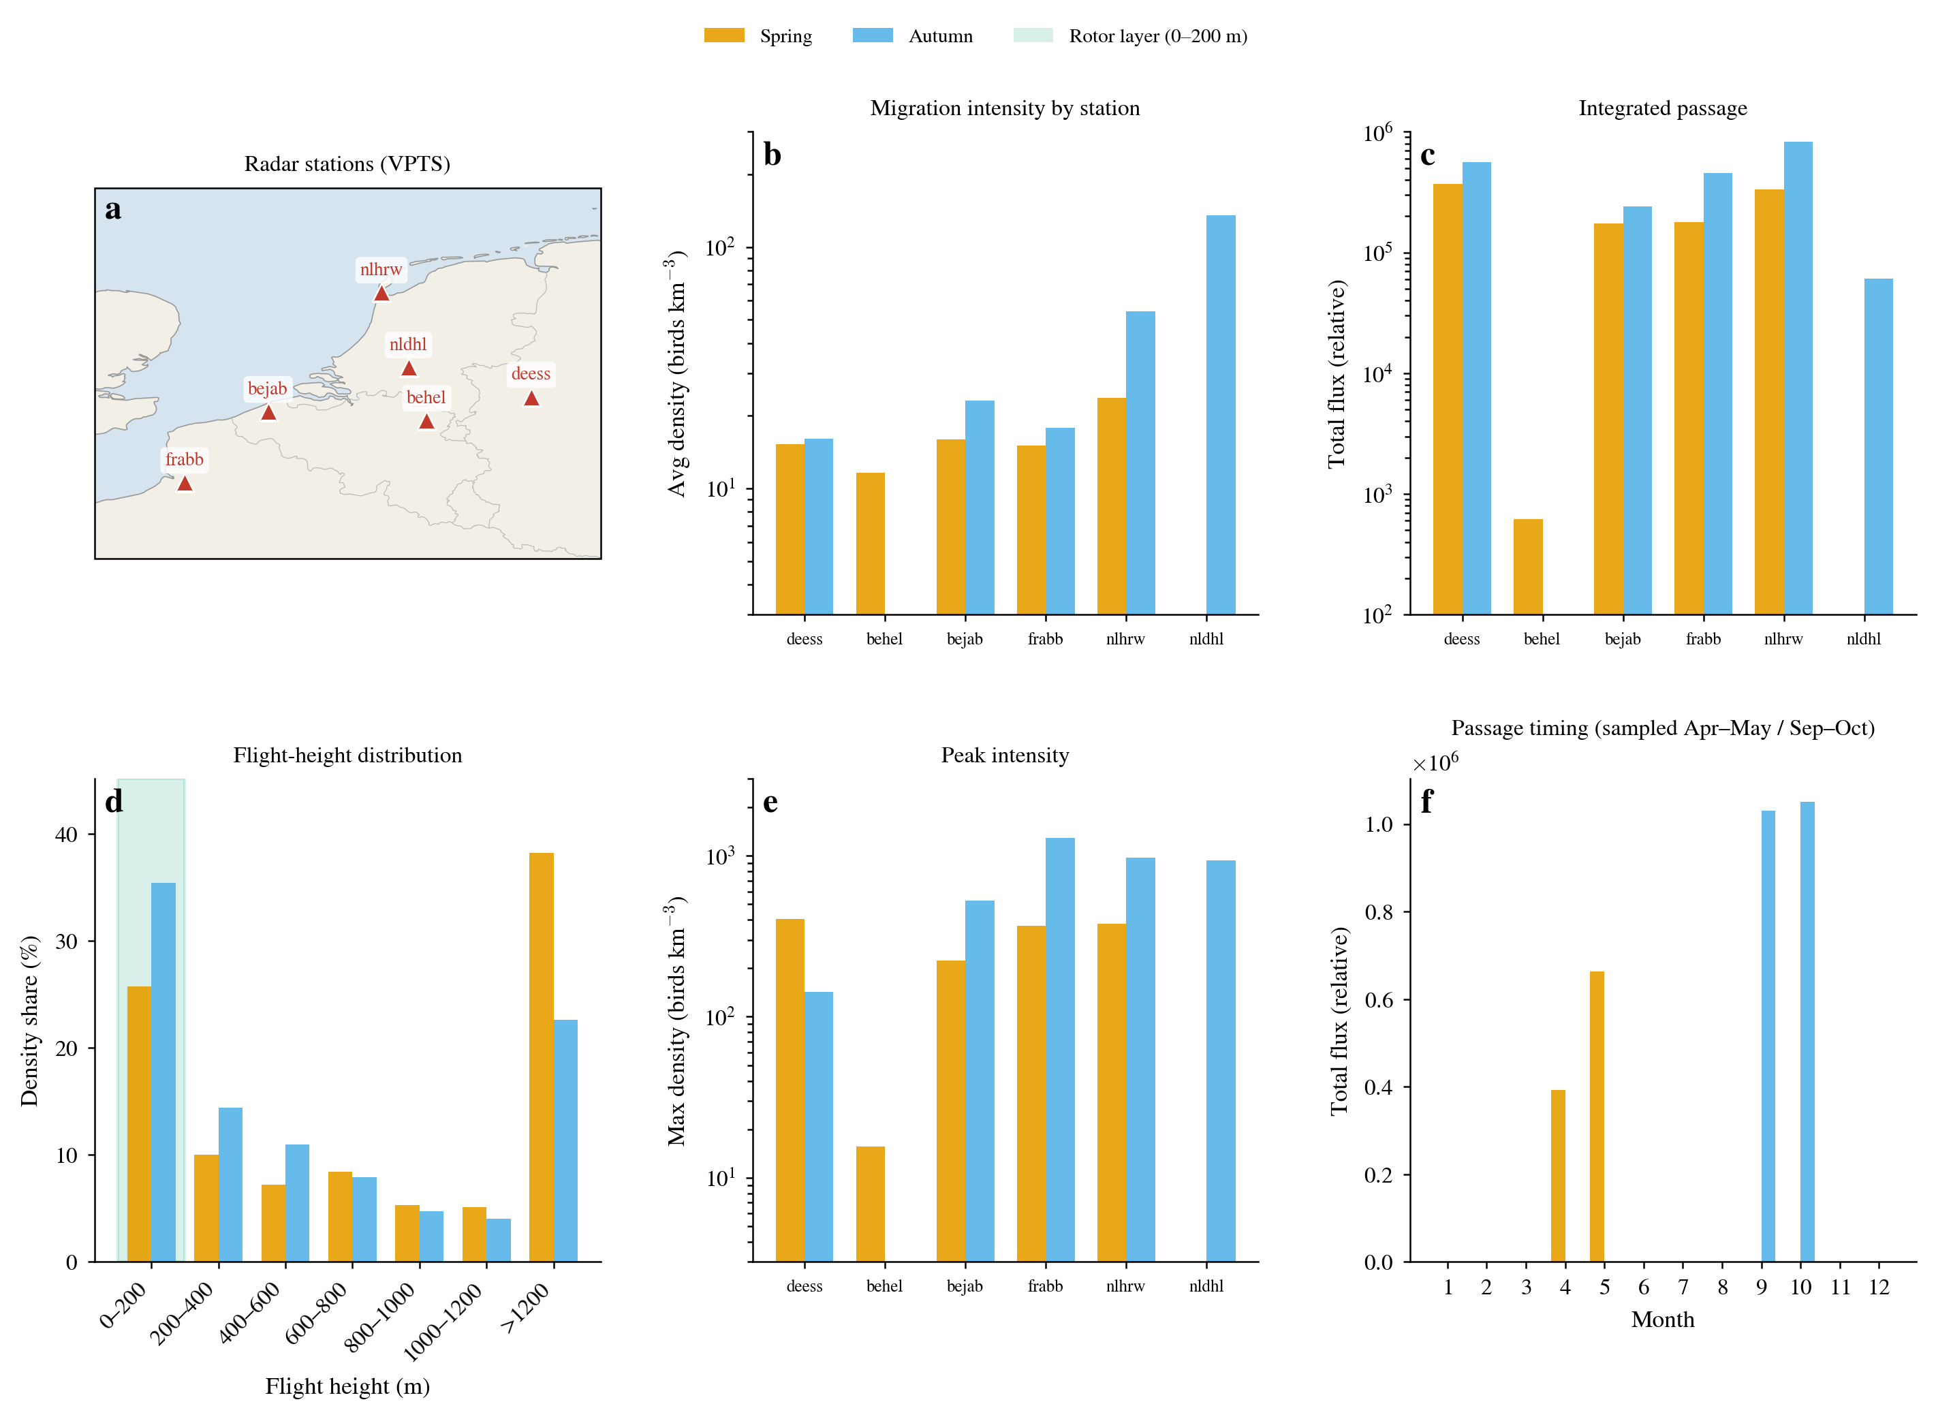
Supplementary Fig. S1 | Quantity, height, and direction of the migratory-bird threat (see Results, first section). Fig. S1a shows the mean spring/autumn density of each radar station (log scale); Fig. S1b the total migration-season flux of each station (log scale); Fig. S1c the flight-height distribution histogram (median fraction in the 0–200 m rotor layer ≈0.51); Fig. S1d the polar distributions of spring and autumn flight directions for each station (spring northward, autumn southward, nearly anti-parallel). Roughly half of the birds enter the rotor-swept height, showing that the height overlap between migratory birds and the turbine rotor layer is a systematic phenomenon, providing the ecological premise for the geometric-exposure analysis.
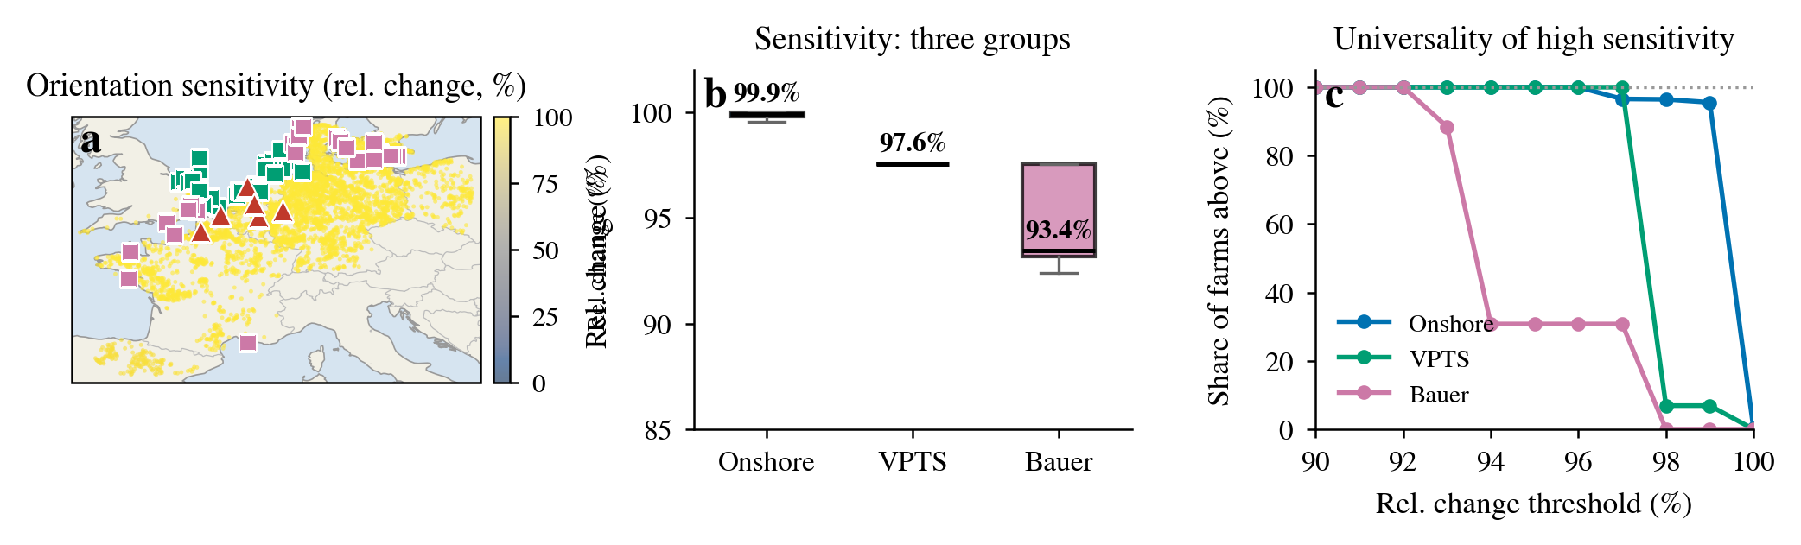
Supplementary Fig. S2 | Spatial universality of directional sensitivity (see Results, first section). Fig. S2a shows the spatial distribution of onshore relative exposure change (rel) (overlaid with the 55 offshore farms and radar stations); Fig. S2b shows box plots of rel for the three groups; Fig. S2c shows the fraction of sites exceeding a given rel threshold (cumulative distribution). The three data sources are independent (onshore pure geometry, VPTS radar measurement, Bauer grid product), yet consistently point to a 93%–100% sensitivity range, supporting the main-text conclusion that orientation sensitivity is a structural feature.

